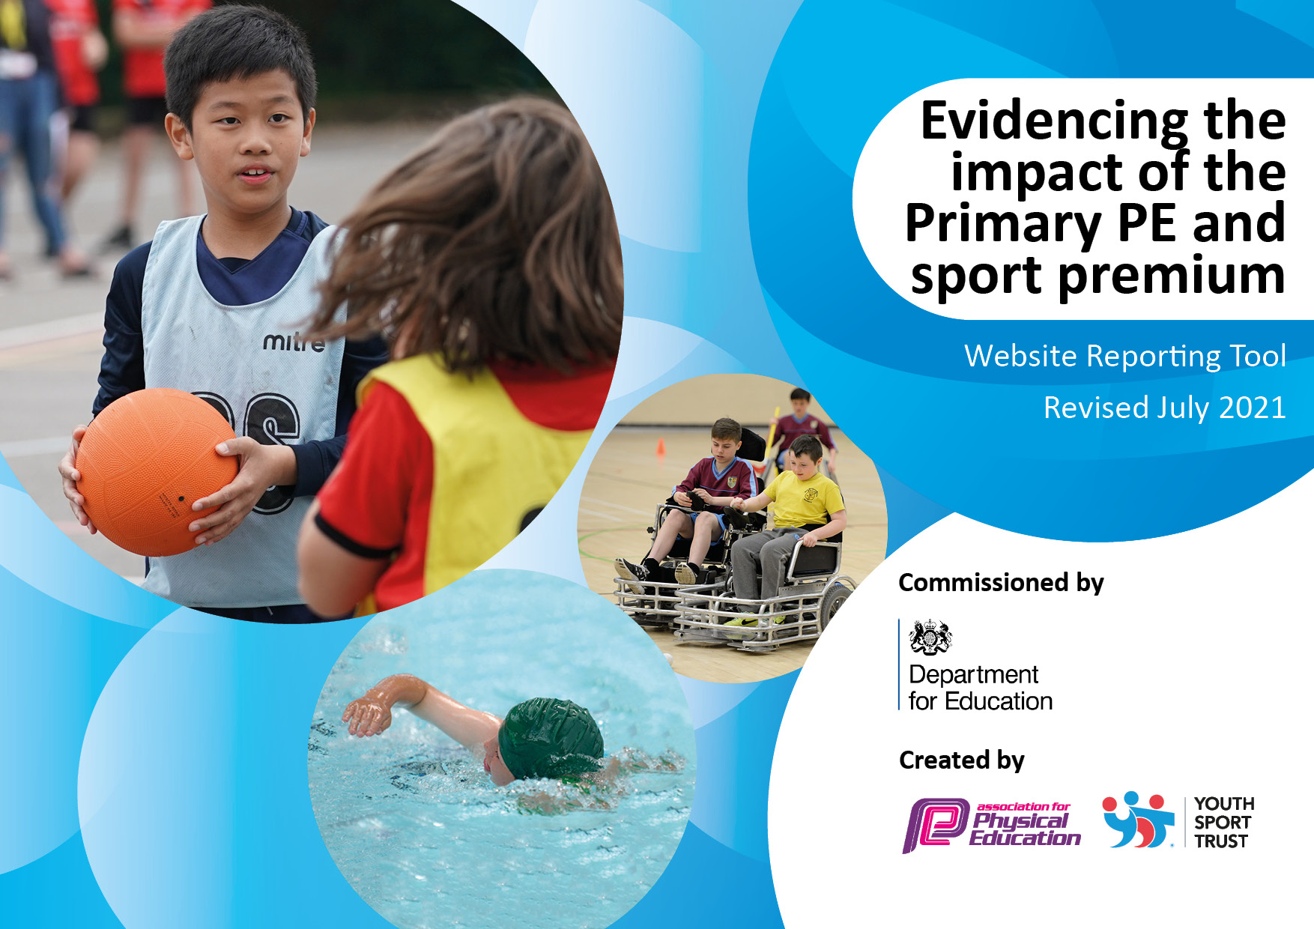
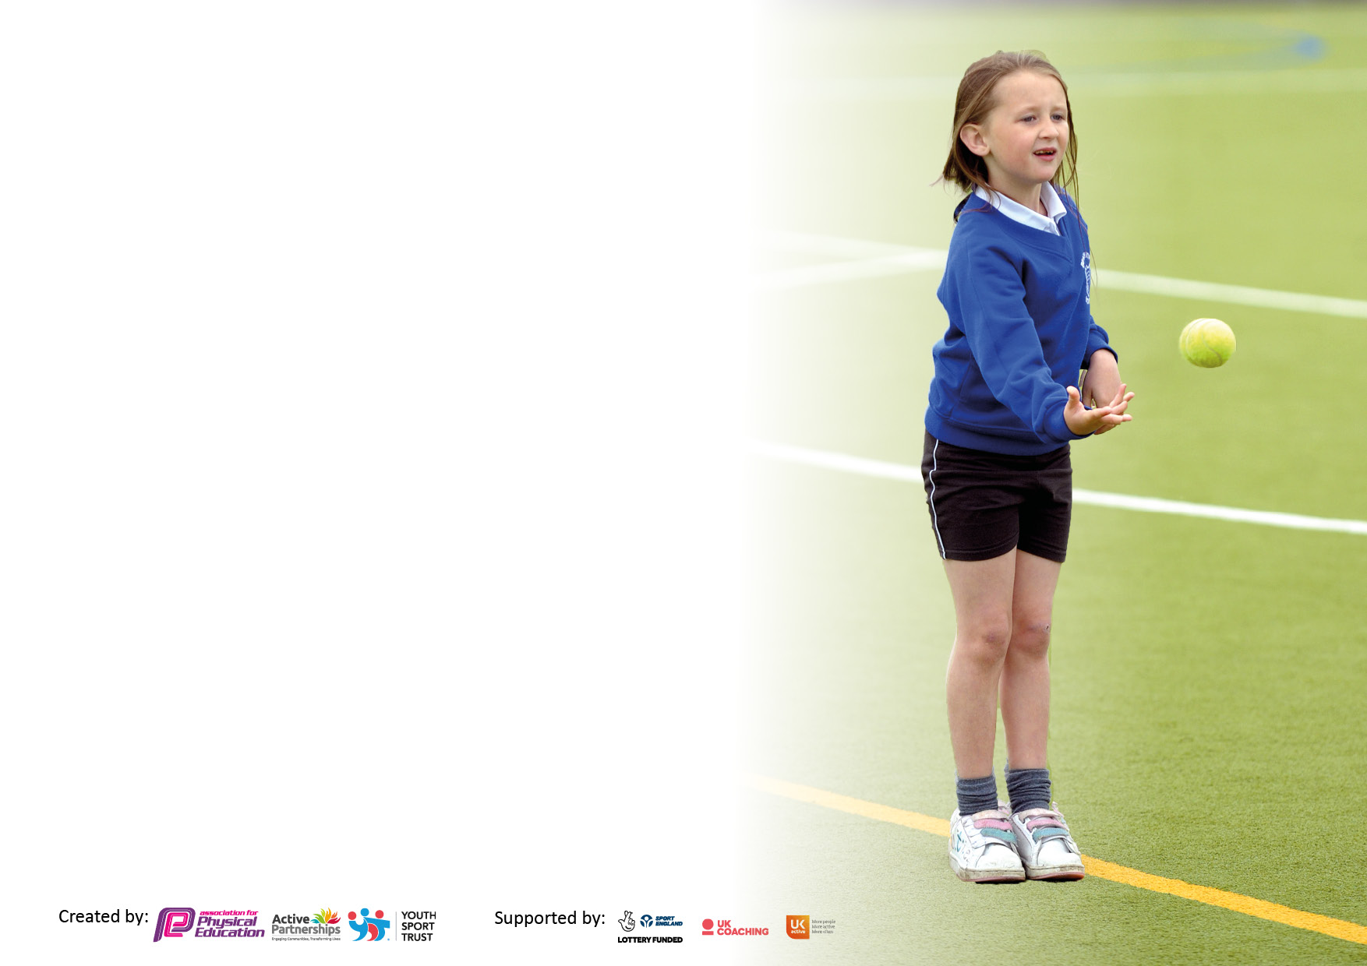

It is important that your grant is used effectively and based on school need. The Education Inspection Framework makes clear there will be a focus on ‘whether leaders and those responsible for governors all understand their respective roles and perform these in a way that enhances the effectiveness of the school’.

Under the Quality of Education Ofsted inspectors consider:
Intent - Curriculum design, coverage and appropriateness
Implementation - Curriculum delivery, Teaching (pedagogy) and Assessment
Impact - Attainment and progress

To assist schools with common transferable language this template has been developed to utilise the same three headings which should make your plans easily transferable between working documents.

Schools must use the funding to make additional and sustainable improvements to the quality of Physical Education, School Sport and Physical Activity (PESSPA) they offer. This means that you should use the Primary PE and sport premium to:

- Develop or add to the PESSPA activities that your school already offer
- Build capacity and capability within the school to ensure that improvements made now will benefit pupils joining the school in future years
- The Primary PE and sport premium should not be used to fund capital spend projects; the school’s budget should fund these.

Pleasevisitgov.ukfortherevisedDfEguidanceincludingthe5keyindicatorsacrosswhichschoolsshoulddemonstrate animprovement.Thisdocumentwillhelpyoutoreviewyourprovisionandtoreportyourspend.DfEencouragesschools to use this template as an effective way of meeting the reporting requirements of the Primary PE and sport premium.

We recommend you start by reflecting on the impact of current provision and reviewing the previous spend.

Schools are required to publish details of how they spend this funding, including any under-spend from 2019/2020, as well as on the impact it has on pupils’ PE and sport participation and attainment. All funding must be spent by 31st July 2022.

We recommend regularly updating the table and publishing it on your website throughout the year. This evidences your ongoing self-evaluation of how you are using the funding to secure maximum, sustainable impact. Final copy must be posted on your website by the end of the academic year and no later than the 31st July 2021. To see an example of how to complete the table please click HERE.
Created by: Supported by:

Details with regard to funding
Please complete the table below.

Total amount carried over from 2019/20 | £697
Total amount allocated for 2020/21 | £2368
How much (if any) do you intend to carry over from this total fund into 2021/22? | £2368
Total amount allocated for 2021/22 | £16970
Total amount of funding for 2021/22. To be spent and reported on by 31st July 2022. | £19338
Swimming Data
Please report on your Swimming Data below.

Meeting national curriculum requirements for swimming and water safety.

N.B. Complete this section to your best ability. For example you might have practised safe self-rescue techniques on dry land which you can then transfer to the pool when school swimming restarts.
Due to exceptional circumstances priority should be given to ensuring that pupils can perform safe self rescue even if they do not fully meet the first two requirements of the NC programme of study
What percentage of your current Year 6 cohort swim competently, confidently and proficiently over a distance of at least 25 metres?  N.B. Even though your pupils may swim in another year please report on their attainment on leaving primary school at the end of the summer term 2021.  Please see note above | 100%
What percentage of your current Year 6 cohort use a range of strokes effectively [for example, front crawl, backstroke and breaststroke]?  Please see note above | 91.6%
What percentage of your current Year 6 cohort perform safe self-rescue in different water-based situations? | 100%
Schools can choose to use the Primary PE and sport premium to provide additional provision for swimming but this must be for activity over and above the national curriculum requirements. Have you used it in this way? | No

Action Plan and Budget Tracking
Capture your intended annual spend against the 5 key indicators. Clarify the success criteria and evidence of impact that you intend to measure to evaluate for pupils today and for the future.

Academic Year: 2020/21 | Total fund allocated: | Date Updated:
Key indicator 1: The engagement of all pupils in regular physical activity – Chief Medical Officers guidelines recommend that primary school pupils undertake at least 30 minutes of physical activity a day in school |  |  |  | Percentage of total allocation:
 |  |  |  | 34.06 %
Intent | Implementation |  | Impact
Your school focus should be clear what you want the pupils to know and be able to do and about  what they need to learn and to  consolidate through practice: | Make sure your actions to achieve are linked to your intentions: | Funding allocated: | Evidence of impact: what do pupils now know and what can they now do? What has changed?: | Sustainability and suggested next steps:
A balanced and progressive PE curriculum (real PE) which focuses on key multi abilities and PE is taught through these abilities: Personal, Social, Cognitive Creative, Physical and Health and Fitness.  Extra-curricular clubs  Active lunchtimes  Increased Outdoor and Adventurous opportunities | Since training in 2020, staff are becoming more confident in the delivery of realPE consolidated over the last academic year since lockdown. Some staff received 6 weeks of CPD in lessons with their class from a fully trained coach from Move More (our network provider).  A more comprehensive programme has been implemented after covid restrictions: multi-sports, cross country, netball/basketball, football, cricket, gardening Funding has been spent on equipment to support active lunchtimes.  We have moved away from bubbles as covid restrictions allow but safe play areas were implemented for children.  KS2 classes had a water sports day in the local vicinity including water rescue knowledge and skills.  A year 3 and 4 two day nature based residential to take place in July 2022. Rock climbing included in this year’s programme.  Continuation of the annual year 5 and 6 three day residential (PGL) | £495 (scheme licence)  £108 equipment safety checks  £768.87 Equipment  £249.18  £1770.16  £900  £130 (support for those on pupil premium)  £200 staff overtime  £379.31 (payment in September for July 2021 staffing costs). £75 MiDAS renewal  £558 (support for those on pupil premium)  £400 staff overtime  £552.53 (payment in September for July 2021 staffing costs) | Fundamental skills continue to improve and a more consistent approach has been achieved throughout the school. The focus on personal skills (resilience and determination) and social skills has been much needed after lockdowns.  These personal and social skills are increasing.  More children have been involved in after school activities impacting health and wellbeing and improving physical skills.  Children are more active with increased equipment and organisation of space. Y 6 buddies/leaders have assisted play with reception and younger children  Increased social interaction and engagement. Full day’s physical activity out of the classroom. Personal resilience, teamwork and knowledge were key focusses.  Increased knowledge (nature) physical activity and independence with an overnight stay. Challenging physical ability and fears.  Personal resilience, teamwork and social skills were key focusses.  Challenging the physical ability, resilience and, in some cases, fear of an activity usually involving height.  Personal resilience, teamwork and social skills were key focusses. | Scheme to be continued and real gym and dance consolidated. PE coordinator will observe and monitor.  Extra-curricular programme to be reviewed and continued in 2022-23  Review and monitor in consultation with MDSA’s  Continue to review and ensure variety across years.  Evaluate and review for 2023  Pioneer centre has been booked for 2023 – a much cheaper alternative to PGL.
Key indicator 2: The profile of PESSPA being raised across the school as a tool for whole school improvement |  |  |  | Percentage of total allocation:
 |  |  |  | 52.7 %
Intent | Implementation |  | Impact
Your school focus should be clear what you want the pupils to know and be able to do and about  what they need to learn and to  consolidate through practice: | Make sure your actions to achieve are linked to your intentions: | Funding allocated: | Evidence of impact: what do pupils now know and what can they now do? What has changed?: | Sustainability and suggested next steps:
Specialist PE coordinator in place | PE specialist responsible for ensuring high quality PE provision in terms of lessons, extra-curricular clubs, active lunchtimes and additional programmes. The wider context of health and well being has become a more prominent focus Weekly information and reports on school newsletter. Noticeboard dedicated to PE.  Photos put on website of ‘special’ activities such OAA programme. | £10195 | School staff are engaged and recently trained for curriculum PE. Staff specialist areas and interests are used for extra-curricular clubs. Staff understand the multi abilities in the real PE scheme are key life skills and also cross curricular benefitting other areas of the curriculum. The link between physical health, mental wellbeing and academic performance is understood by staff. | To be continued

Key indicator 3: Increased confidence, knowledge and skills of all staff in teaching PE and sport |  |  |  | Percentage of total allocation:
 |  |  |  | 0 %
Intent | Implementation |  | Impact
Your school focus should be clear | Make sure your actions to | Funding | Evidence of impact: what do | Sustainability and suggested
what you want the pupils to know | achieve are linked to your | allocated: | pupils now know and what | next steps:
and be able to do and about | intentions: |  | can they now do? What has
what they need to learn and to |  |  | changed?:
consolidate through practice:
Staff training in real gym (continued development from realPe training in 2020 | Since training in 2020, staff are becoming more confident in the delivery of realPE consolidated over the last academic year since lockdown. Some staff received 6 weeks of CPD in lessons with their class from a fully trained coach from Move More (our network provider) in term 3 (Jan/Feb 2022) | £ part of Move More memberships which includes CPD (total cost of membership under KI 5) | Fundamental skills are improving and a more consistent approach has been achieved throughout the school. The focus on personal skills (resilience and determination) and social skills continues to be needed after lockdowns. | Ensure real gym and real dance schemes are understood and implemented in 2022-23
Key indicator 4: Broader experience of a range of sports and activities offered to all pupils |  |  |  | Percentage of total allocation:
 |  |  |  | 1.86 %
Intent | Implementation |  | Impact
Your school focus should be clear | Make sure your actions to | Funding | Evidence of impact: what do | Sustainability and suggested
what you want the pupils to know | achieve are linked to your | allocated: | pupils now know and what | next steps:
and be able to do and about | intentions: |  | can they now do? What has
what they need to learn and to |  |  | changed?:
consolidate through practice:
Additional achievements:  More OAA opportunities offered in addition to current provision in lessons for KS2 (problem solving activities and games and orienteering) and PGL residential offered to year 5 and year 6 children.  All children, particularly years 5 and 6 received additional OAA lessons from a PGCE student with particular expertise in this area.  A second residential experience will be introduced for years 3 and 4.  ‘Balanceability’ programme to ensure reception children reach targets in term of balance and learning to ride.  All KS2 children to gain a first aid qualification/training | KS2 classes had a watersports day (caneoing) including water safety and rescue.  Continuation of the annual year 5 and 6 three day residential (PGL).  A year 3 and 4 two day nature based residential to take place in July 2020.  All reception children received balancability training.  Live Life Adventure (trained staff) taught the mini medics course to all KS2 children | As indicated in KI 1  £0 (as part of PE coordinator role)  £360 | Increased social interaction and engagement as part of a recovery programme post the summer 2020 lockdown. Full day’s physical activity out of the classroom.  Challenging the physical ability, resilience and, in some cases, fear of an activity usually involving height.  Increased knowledge (nature) physical activity and independence with an overnight stay. Climbing was added to the activities to increase challenge and personal resilience.  Greater ability to balance and control a bike. Awareness of safety: Their own and that of others.  Awareness of basic first aid skills and how to help (and call an adult for help). | More opportunities for OAA (day trips)to be implemented next year.  The Pioneer centre, near Kidderminster has been booked for Y 5 and 6 residential in 2023.  To be evaluated and discussed for 2023.  To be continued.  Potential for expanding first aid training/awareness to KS1

Key indicator 5: Increased participation in competitive sport |  |  |  | Percentage of total allocation:
 |  |  |  | 12.5%
Intent | Implementation |  | Impact
Your school focus should be clear | Make sure your actions to | Funding | Evidence of impact: what do | Sustainability and suggested
what you want the pupils to know | achieve are linked to your | allocated: | pupils now know and what | next steps:
and be able to do and about | intentions: |  | can they now do? What has
what they need to learn and to |  |  | changed?:
consolidate through practice:
To ensure a greater number of children take part in extra-curricular events, even if not competitive. Membership with Move More provides competition in addition to staff CPD, curriculum support, and more. | A full programme of inter school events and competitions was available this academic year including an increased focus on engaging less active children. | £2200.00  £218.10 transport costs | All children in KS2 took part in at least 1 extra-curricular event ranging from traditional games, cross country and athletics to archer, orienteering, tri-golf and a Commonwealth games wellbeing day. Twyning were highly successful winning trophies in cross country and rounders and had 4 children reach the county championships in cross country as part of the Tewkesbury district team.  Leadership opportunities were also included – all year 6 pupils had an opportunity to lead activities and officiate at Twyning Playgroup sports day and/or the Year 3 and 4 Quad kids athletics event. | Continue to enter children into a full range of activities and opportunities suitable for the individuals selected.  Encourage, promote and provide information for children to move into local sports clubs/activities.

Signed off by
Head Teacher: | 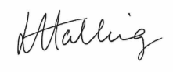
Date: | 28.7.22
Subject Leader: | J. Leggett
Date: | 19/07/22
Governor:
Date: | 30/7/22

