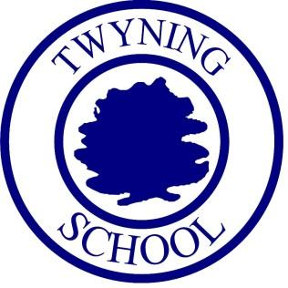

Twyning School
Phonics: Information booklet for parents/ carers

Date Created: | September 2021
Last reviewed on:
Next review due by: | September 2022
Governor Committee: | Communications and Standards

Overview
Phonics teaching and learning is the first and fast approach to teaching children to read. At Twyning School, we follow a complete systematic synthetic phonics programme called ‘Little Wandle Letters and Sounds Revised’.

‘Synthetic phonics refers to an approach to the teaching of reading in which the phonemes [sounds] associated with particular graphemes [letters] are pronounced in isolation and blended together (synthesised). For example, children are taught to take apart a single-syllable word such as cat into its three letters, pronounce a phoneme for each letter in turn /k, æ, t/, and blend the phonemes together to form a word. Synthetic phonics for writing reverses the sequence: children are taught to say the word they wish to write, segment it into its phonemes and say them in turn, for example /d, o, g/, and write a grapheme for each phoneme in turn to produce the written word, dog.’

Phonics teaching is split into five phases with the different phases being covered through Early Years and Year 1. This booklet will give you an idea of what is expected in each phase.

By the end of Reception, we aim for all children to be very familiar with the sounds in phase 3 and becoming secure at phase 4. This means that Year 1 can focus on phase 5. Some children will need to revisit these sounds in Year 1. This booklet will outline how we support children not making the progress desired. By the end of Year 1, we aim for all children to use and apply all aspects of phase 5.

Terminology & Definitions
Phoneme
The smallest unit of sound.

Grapheme
The written representation of a phoneme.

Oral blending
This is when the child ‘pushes together’ phonemes given by an adult.

Oral segmenting
This when the child ‘pulls a part’ a spoken word by an adult.

Blending
The process in which phonemes are ‘pushed together’ to make a word.

Segmenting
The process in which phonemes are ‘pulled a part’ to identify the phonemes in a word.

Phonological Awareness
Phonological awareness is a broad skill that includes identifying and manipulating units of oral language – parts such as words, syllables, and onsets and rimes. Children who have phonological awareness are able to identify and make oral rhymes, can clap out the number of syllables in a word, and can recognise words with the same initial sounds like 'money' and 'mother.'

Decodable words
These are words that children can use their phonic knowledge to decode.
Tricky words
High-frequency words that, although decodable in themselves, cannot be decoded by children using the GPCs they have been taught up to that point. Not all high-frequency words are ‘tricky words’. Many tricky words cease to be tricky in the later stages of the programme, as more GPCs are learned.

Alien words
These are nonsense words. They are words that can be decoded but test pure phonetic knowledge.

Polysyllabic / Multisyllabic
These are words that have more than one syllable.

Digraph
Two letters but only one sound. [Letter names must be used for digraphs].

Trigraph
Three letters but only one sound. [Letter names must be used for trigraphs].

Alphabetic code
The relationship between the sounds that can be identified in speech (phonemes) and the letters used to represent them in writing (graphemes).

Alternative pronunciation
A different way of pronouncing a grapheme. For example, the letters ‘ow’ can represent the sounds /ow/ as in ‘crown’ and /oa/ as in ‘snow’.

Alternative spelling
A different way of spelling a phoneme. For example, the sound /w/ can be represented in writing by ‘w’ as in ‘wave’ and ‘wh’ as in ‘what’.

Compound word
A word made by joining two individual words together, for example, ‘houseboat’ is ‘house’ + ‘boat’.

Fluency
The ability to read accurately with speed and expression. Fluent readers read words automatically without needing to decode. It is at this point that we see them able to focus on comprehension and make sense of what is being read.

Formation phrase
A memorable phrase used to support the children in forming the letter correctly using directional vocabulary, such as ‘down’, ‘up’, ‘across’ and ‘over’.

Under the snake’s chin, slide down and round its tail.

Mnemonic
Any simple device used to assist memory. In this programme, it is a combination of an engaging picture with a letter and is used as a ‘hook’ to help children remember a particular GPC when they first learn it.

Sound button
A graphic device to help children recognise the separate phonemes in a printed word. Sound buttons can be used as a support in the early stages of learning. For each word, a dot is placed under any single-letter grapheme and a short horizontal line under the group of letters that form a digraph or trigraph, as shown below.

Split vowel digraph
A digraph that is split by another phoneme – e.g. cake / huge / make.

Best fit
This is a strategy to help children when deciding on alternative spelling patterns for encoding.

Decoding
This is the process of reading words.

Encoding
This is the process of spelling words.

Consonant
These are letters in the alphabet that are non-vowel sounds.

Vowel
These are – a, e, i, o, u. CVC ‘Consonant letter-Vowel letter-Consonant letter’ word, for example, c-a-t.

Adjacent consonants
Two or more consonants that come together in a word without any intervening vowel or vowels (for example, ‘dr’ in ‘drop’, ‘s-t-r’ in ‘strap’). Adjacent consonants do not constitute a discrete unit of sound and are read by blending the individual consonant phonemes involved.

Vowel Digraphs
Digraphs that only contain vowels.

Grapheme / Phoneme Correspondence (GPC)
The ability to link a heard phoneme to the appropriate grapheme and vis versa.

Strategies for Decoding and Encoding

Point and sweep
A technique for reinforcing the process of sounding and blending involving the teacher pointing to each phoneme in a word, in sequence from left to right, and then sweeping a finger below the word, again from left to right, to indicate the blending. It can be used with the teacher and/or children vocalising each stage, or as a reinforcement to silent sounding and blending as children become more confident.

Overt blending aloud
Sound-talking aloud every phoneme in turn before blending them together to form the word.

Sound Talk
A technique for the early practice of blending. The teacher articulates each phoneme in a word separately, in order, and children respond by saying the whole word aloud. Alternatively, they can be asked to blend the word silently and show they have done so by responding with some action, for example, touching their head, after the teacher has pronounced the separate phonemes in the word ‘head’. Such practice is valuable both before and during the early stages of learning to read.

Chunk it up
To break up a longer word and read it one part (chunk) at a time, to avoid being overwhelmed and to ease the process of blending.

Whisper blending
An intermediary stage that can help children bridge the gap between sounding and blending aloud and doing the process silently ‘in their head’.

Speedy sounds
The rapid recall of previously taught GPCs.

Sound buttons to blend
A strategy to help children to blend for decoding.

Blend in your Head
This is a strategy used to ensure children build their fluency.

Foundations to Phonics

Foundations to Phonics is the start to your child becoming a confident and proficient reader.

Auditory Discrimination
Can your child hear the difference between the words? Do they hear the words as the ‘same or not the same’? ship / shop (no / not the same) ship / ship (yes / same) cat / cot (no / not the same) cat / cat (yes / same)

Initial Sounds
Ensuring children can identify the initial sound in a word is a great place to start. tin - starts with the sound /t/ mop - starts with the sound /m/.

Syllables
Can your child clap the beat of a word? How many syllables do these words have? What about your child’s name - can they clap the syllables in their name?

Sound Isolation
Being able to listen to and isolate phonemes in a word is an excellent skill. Give opportunities for your child to find the phonemes at the beginning and end of words as well as phonemes in the middle. What is the phoneme in the middle of the word ’bag’? What is the phoneme at the beginning of the word ’sun’? What is the phoneme at the end of the word ‘mud’?

Sound Deletion
Playing with phonemes and being able to mess with them in words will allow your child to read and write with ease. Can you help your child delete phonemes to make different words? Try taking away the beginning phoneme and the last phoneme in the word. If I had the word ‘cat’ and took away the /c/ phoneme - what would the new word be? If I had the word ‘tent’ and took away the last sound (/t/) - what would the new word be?

Alliteration
Have fun with words! Teach your child some tongue twisters! Can they hear the phoneme that starts each word? ‘Flapping flamingos fly fast’ ‘Jump like jolly jumping jelly’.

Syllable Isolation
Being able to listen to and isolate syllables in a word is an excellent skill. Give opportunities for your child to listen to different syllables in a word. To help, you can emphasise the correct part of the word. What is the syllable in the middle of the word ‘computer’? What is the syllable at the beginning of the word ‘printer’? What is the syllable at the end of the word ‘table’’?

Syllable Deletion
Can you delete a syllable from a word and say what is left? You don’t have to finish on a real word! What is the word ‘turnip’ without the last syllable? What is left when you take the last syllable from ‘magnet’? What is left from ‘paper’ when you take away the first syllable?

Rhyme - Identify
Can your child hear when two words rhyme? Words rhyme when they sound the same at the end. Does ‘ship’ and ‘chip’ rhyme? Yes - they sound the same at the end. Sh-ip and ch-ip. Does ‘bat’ and ‘cat’ rhyme? Yes - they sound the same at the end. B-at and c-at. Rhyme - Continue a rhyming string Can you help your child continue a list of words that rhyme? You might accept nonsense words too! cat, bat, sat, ____, _____, _____, ____, ____ pot, cot, ___, ___, ___, ___ sound, pound, ___, ___, ___, ____ Can your child identify the sound at the end of each word that sounds the same?

Oral blending
Can you say some phonemes that your child can push together in the brain so they can hear and say a word? For this, you don’t write anything down. It is a listening task. Can you push these phonemes together? c-a-t What word can you hear? c-a-t Can you push these phonemes together? m-u-d What word can you hear? m-u-d

Oral segmenting
Can your child listen to a word and then tell you what phonemes there are in it? Again, for this task you don’t write anything down. It is a listening task. Can your child pull the word a part? What phonemes can you hear in ‘mop’ Hold the word and chop it up. ‘m…o...p’ What phonemes can you hear in ‘tin’ Hold the word and chop it up. ‘t…i...n’ You could ask specifically - what phoneme can you hear at the beginning, at the end or in the middle?

The main message for Foundations to Phonics...have lots of fun! Experiment with sounds.

Music - listen to music
Sing songs together! Music is such a fantastic tool to support early reading development. Children become aware of beats and patterns. They develop their listening and attention skills. They tune their ears to hear. The ability to discriminate and isolate phonemes will be strengthened if your child has a love of music!

Foundations to Phonics develops a lot of language concepts too! Check your child understands the different language you are using.
same different not the same first middle final last end beginning push pull what’s left? take away delete start between beat word how many?

Phase 2
This is the phase in which children are introduced to the phoneme / grapheme correspondences. This means that each letter they see written down (grapheme), they will learn what the phoneme (sound) is. At this phase, children do not use the letter names yet. Just letter sounds. We must pronounce the phonemes correctly so do click on the links below to hear how each phoneme is pronounced correctly.
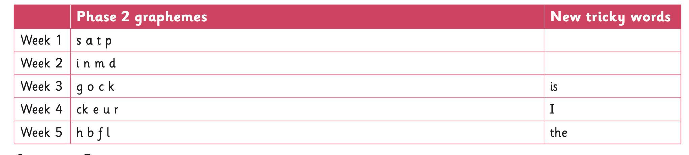
During Autumn 1 of Reception, your child will learn the following:
Click the link to hear how each phoneme should be pronounced: https://www.youtube.com/embed/shlSQrleibs?rel=0

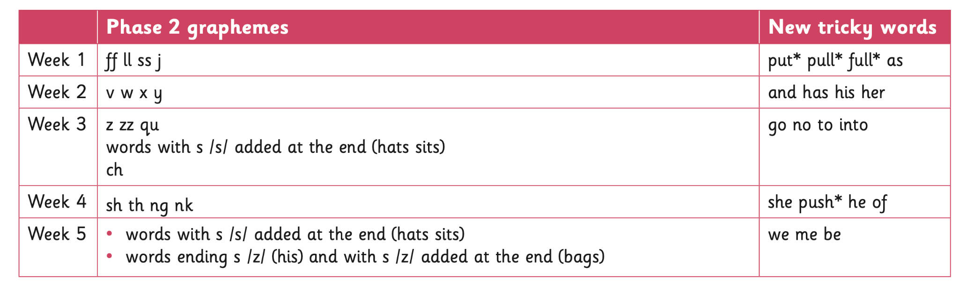
Autumn 2 of Reception, will cover the following sounds:

Click the link to hear how each phoneme should be pronounced:
https://www.youtube.com/embed/tKUEQFXXfYY?rel=0

For each sound, we use a rhyme. This helps the children to remember their learning and it also helps with their letter formation.

As your child learns each phoneme, they will learn:
• how the grapheme looks
• What the phoneme sounds like
• To match the phoneme to the grapheme
• How to write the grapheme correctly.

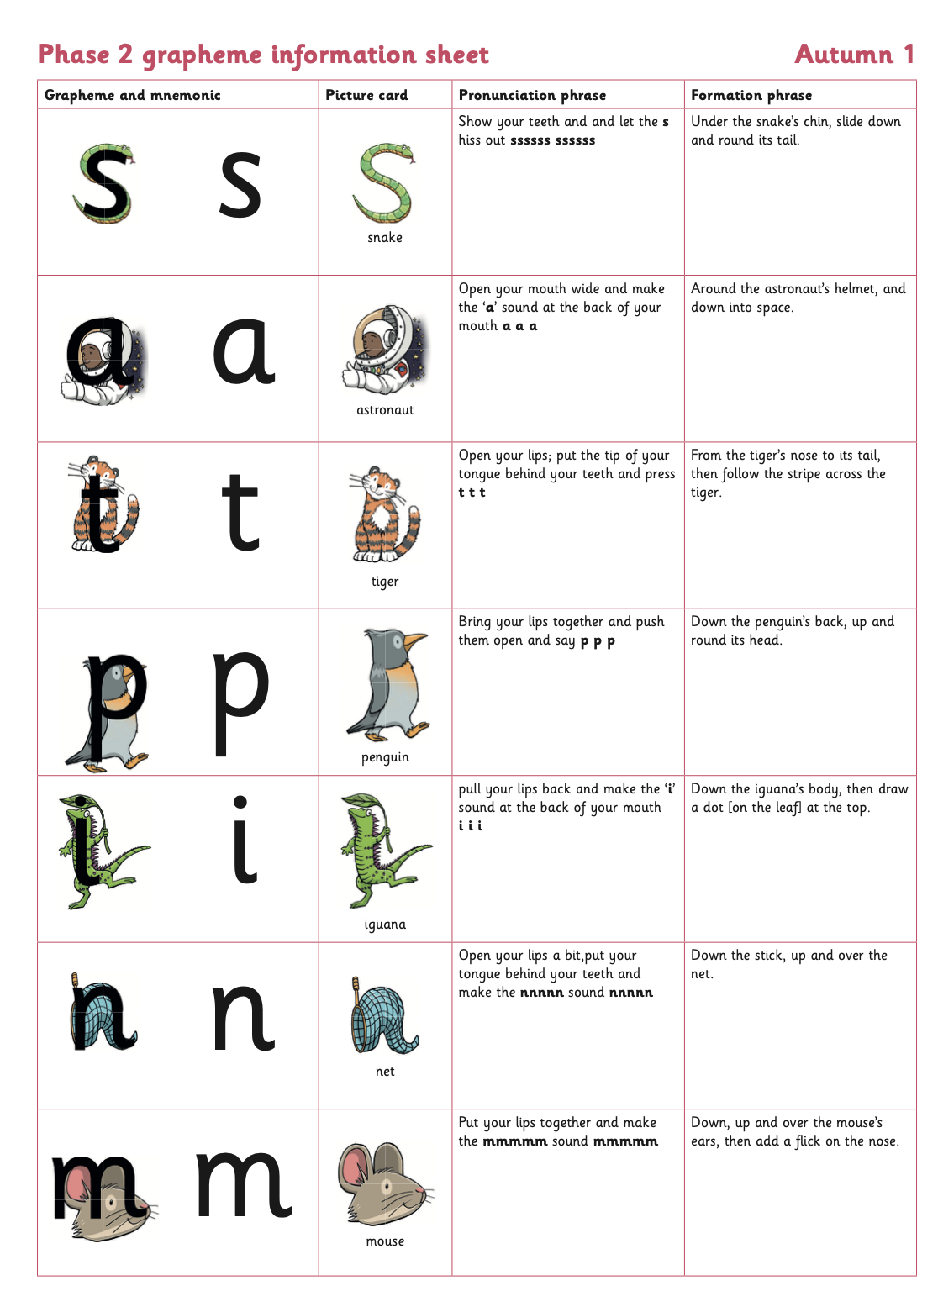

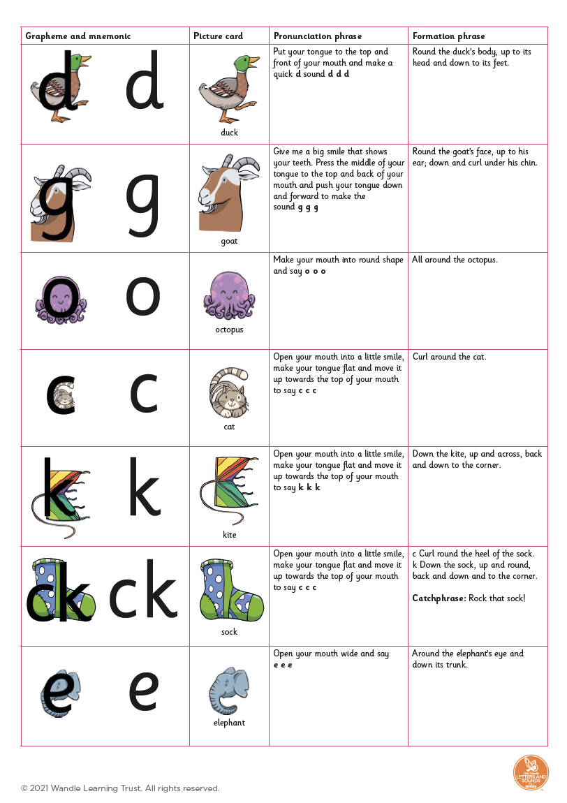
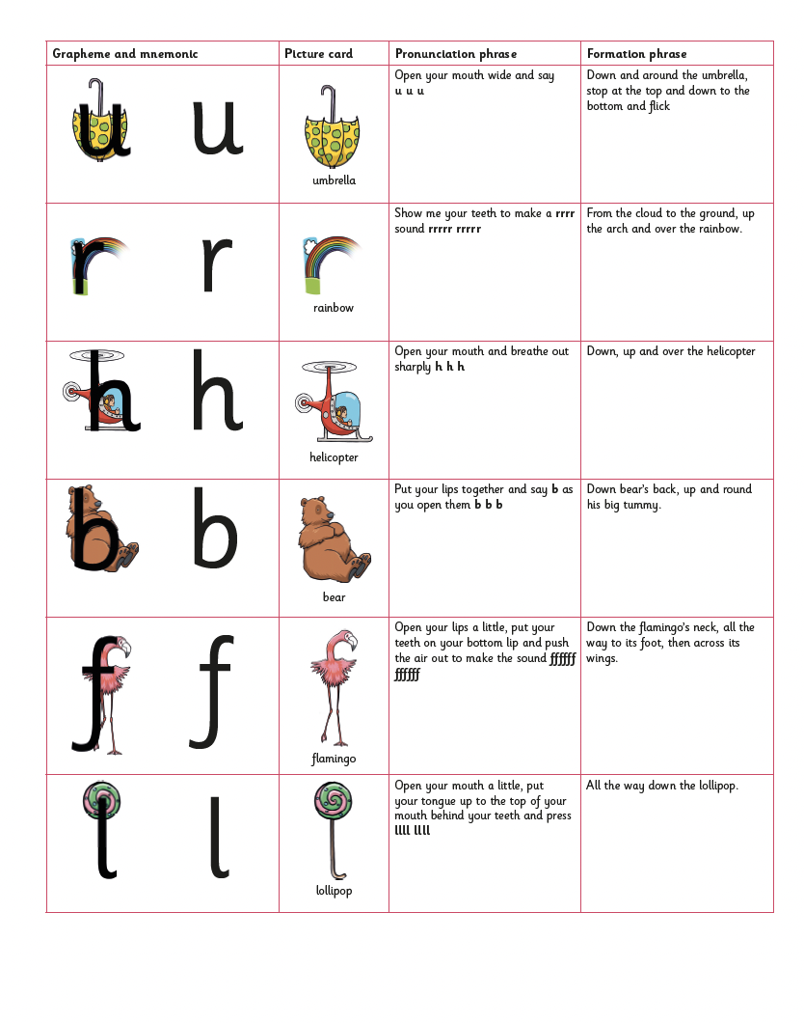

Terminology and actions to use with children - a reminder!

If you want your child to read a word that is written down, ask them to ‘press the sound buttons’. Your child should then use their pointy finger to press an imaginary button under each grapheme and say the corresponding phoneme. As they press the final sound button they then need to blend the phonemes together to make the word. If they struggle, you could help by reminding them of the process, saying the phonemes for them or just saying the phonemes slightly quicker so your child can hear the word coming together easier. Remember...if you help your child, get them to do it with increasing independence straight away.

If you want your child to write a word down you have said or they want to write ask them to use their ‘phoneme fingers’. Your child should then say the target word and then tap a finger on their chin. Each finger should correspond to a phoneme. They may wish to write down each phoneme as they go.

Phase 3

This is the phase in which children are introduced to one way of reading and spelling a phoneme. This phase introduces:
Digraphs - two letters but only one sound.
Trigraph - three letters but only one sound Letter names At this phase, when children are saying which letters are used to make up a digraph and/or trigraph, they must be encouraged to use the letter names not the letter sounds.

During Spring 1 of Reception, your child will learn the following:

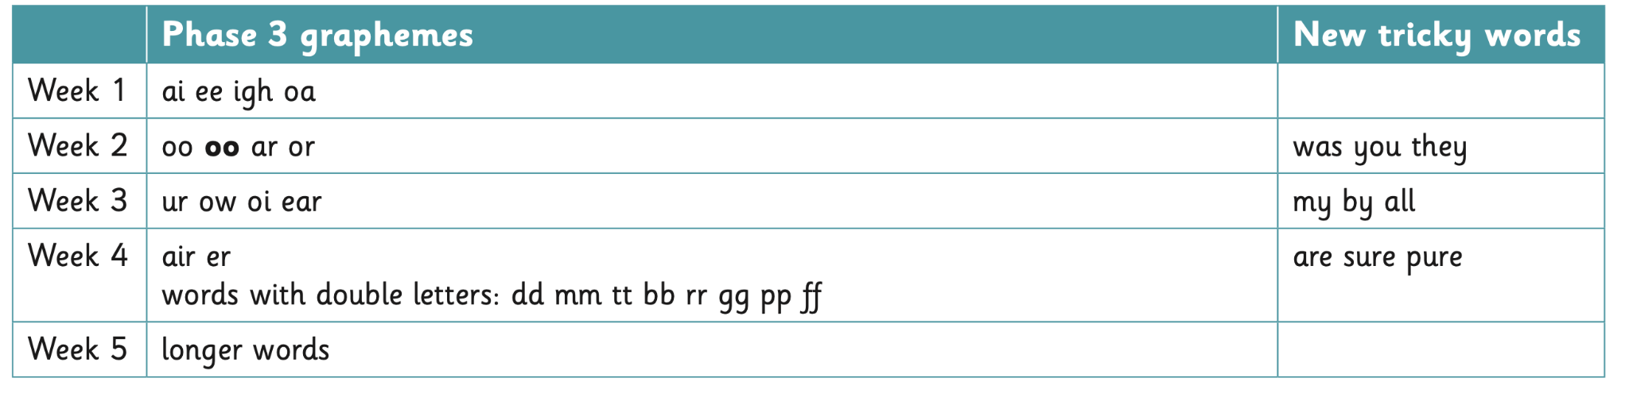

Click the link to hear how each phoneme should be pronounced: https://player.vimeo.com/video/559977526?rel=0

During Spring 2 of Reception, your child will learn the following:

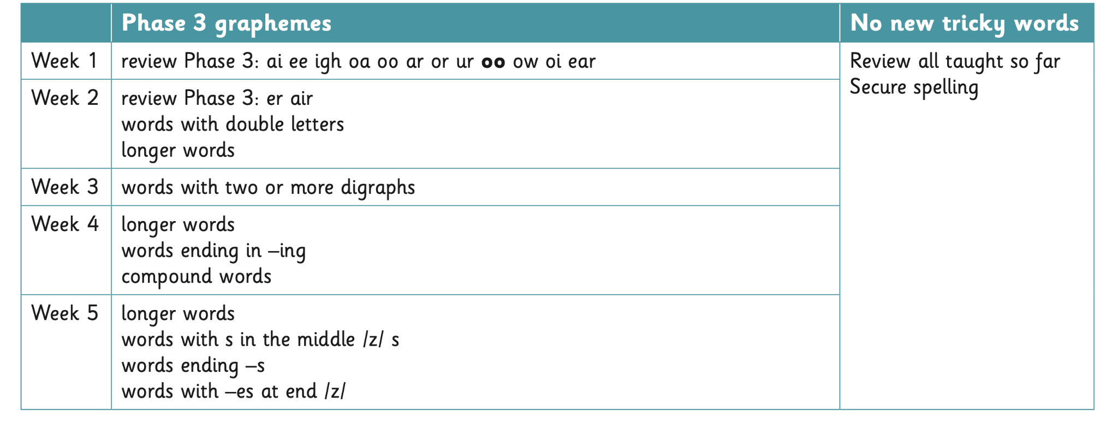

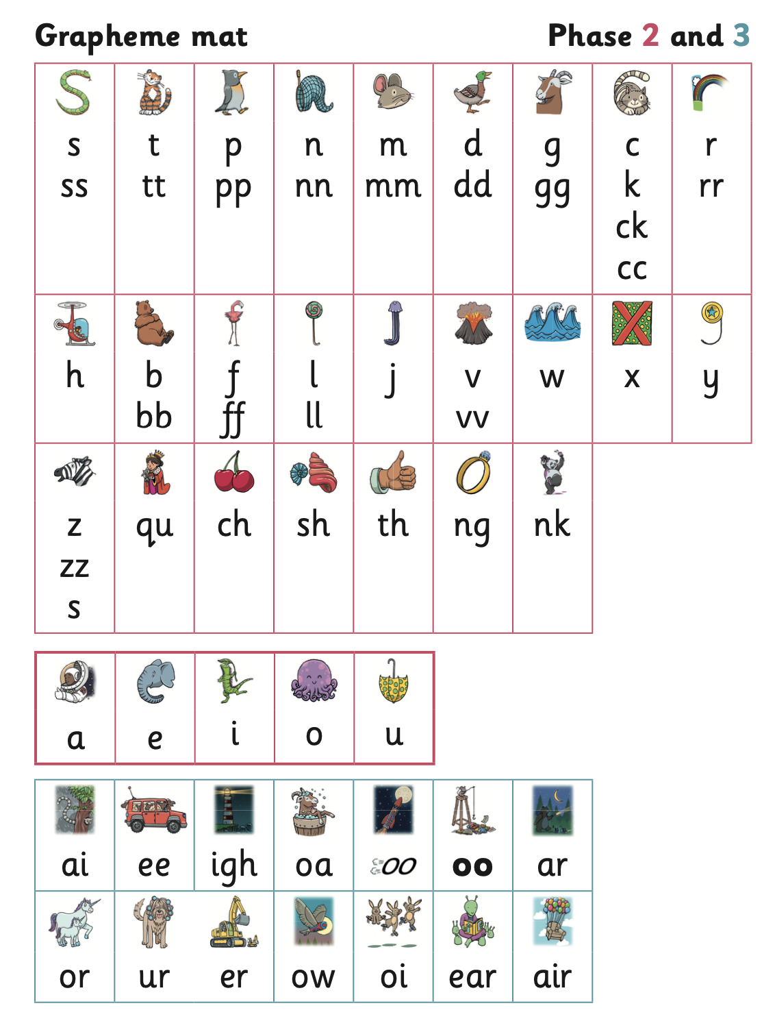

Phase 4

At phase 4, your child will not learn any new phoneme or graphemes but they will start to read words with adjacent consonants. This means two consonants together either at the beginning of the a word, the end of a word or both. We call them ‘sneaky sounds’ as they are trying to hide from the children! This will test their listening skills! Examples: black (ccvc word) felt (cvcc word) strong (cccvc word) blank (ccvcc word)

During Summer 1 of Reception, your child will learn the following:
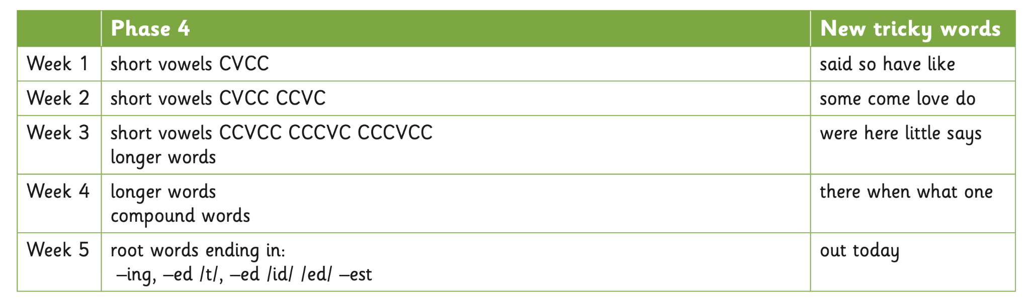
During Summer 2 of Reception, your child will learn the following:
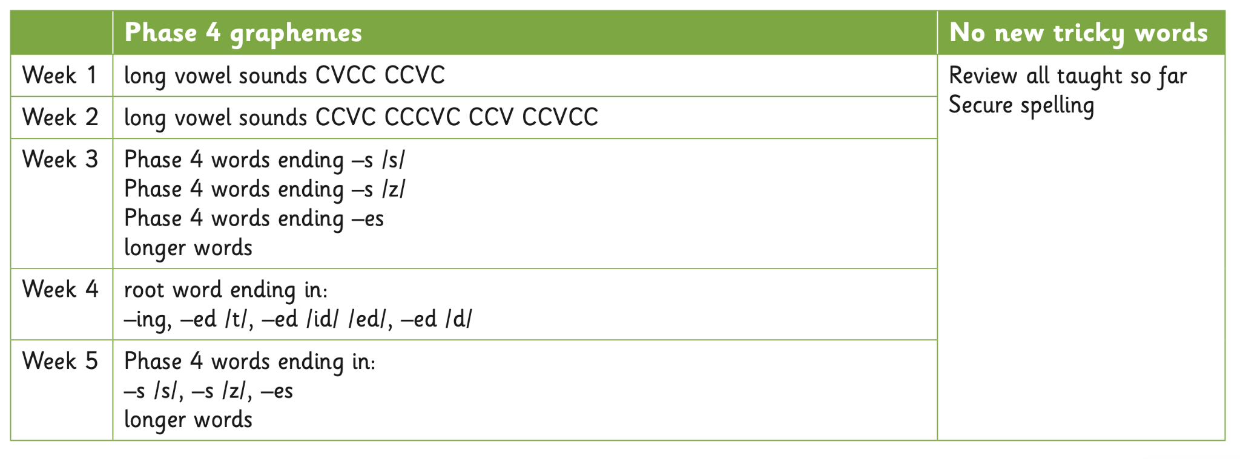

Phase 5
Phase 5 is where children learn more new ways! The English language is hard! Your child will learn the alternative ways to pronouncing and spelling patterns to those they learned in Phase 3. There are 140 letter combinations. Be honest with your child...let them know it is difficult!

During Autumn 1 of Year 1, your child will learn the following:

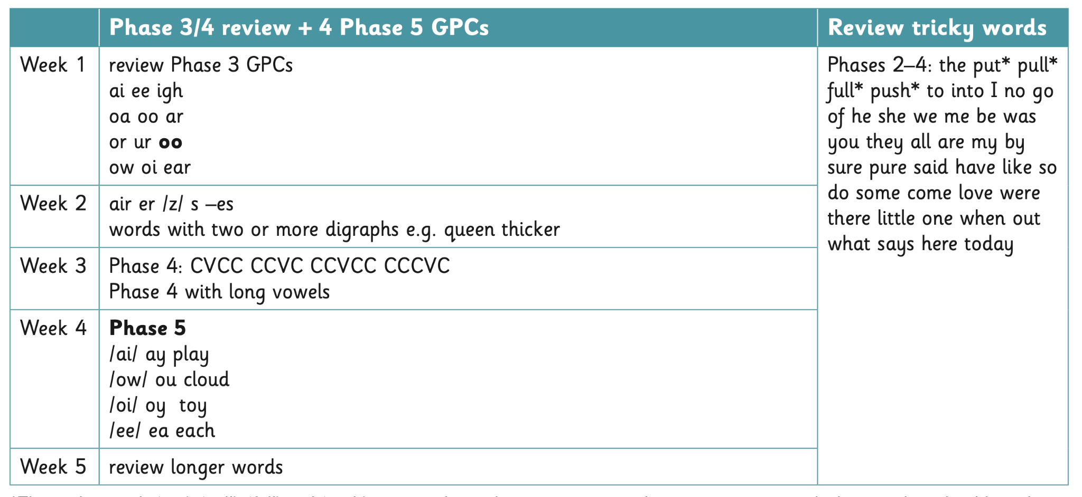

During Autumn 2 of Year 1, your child will learn the following:
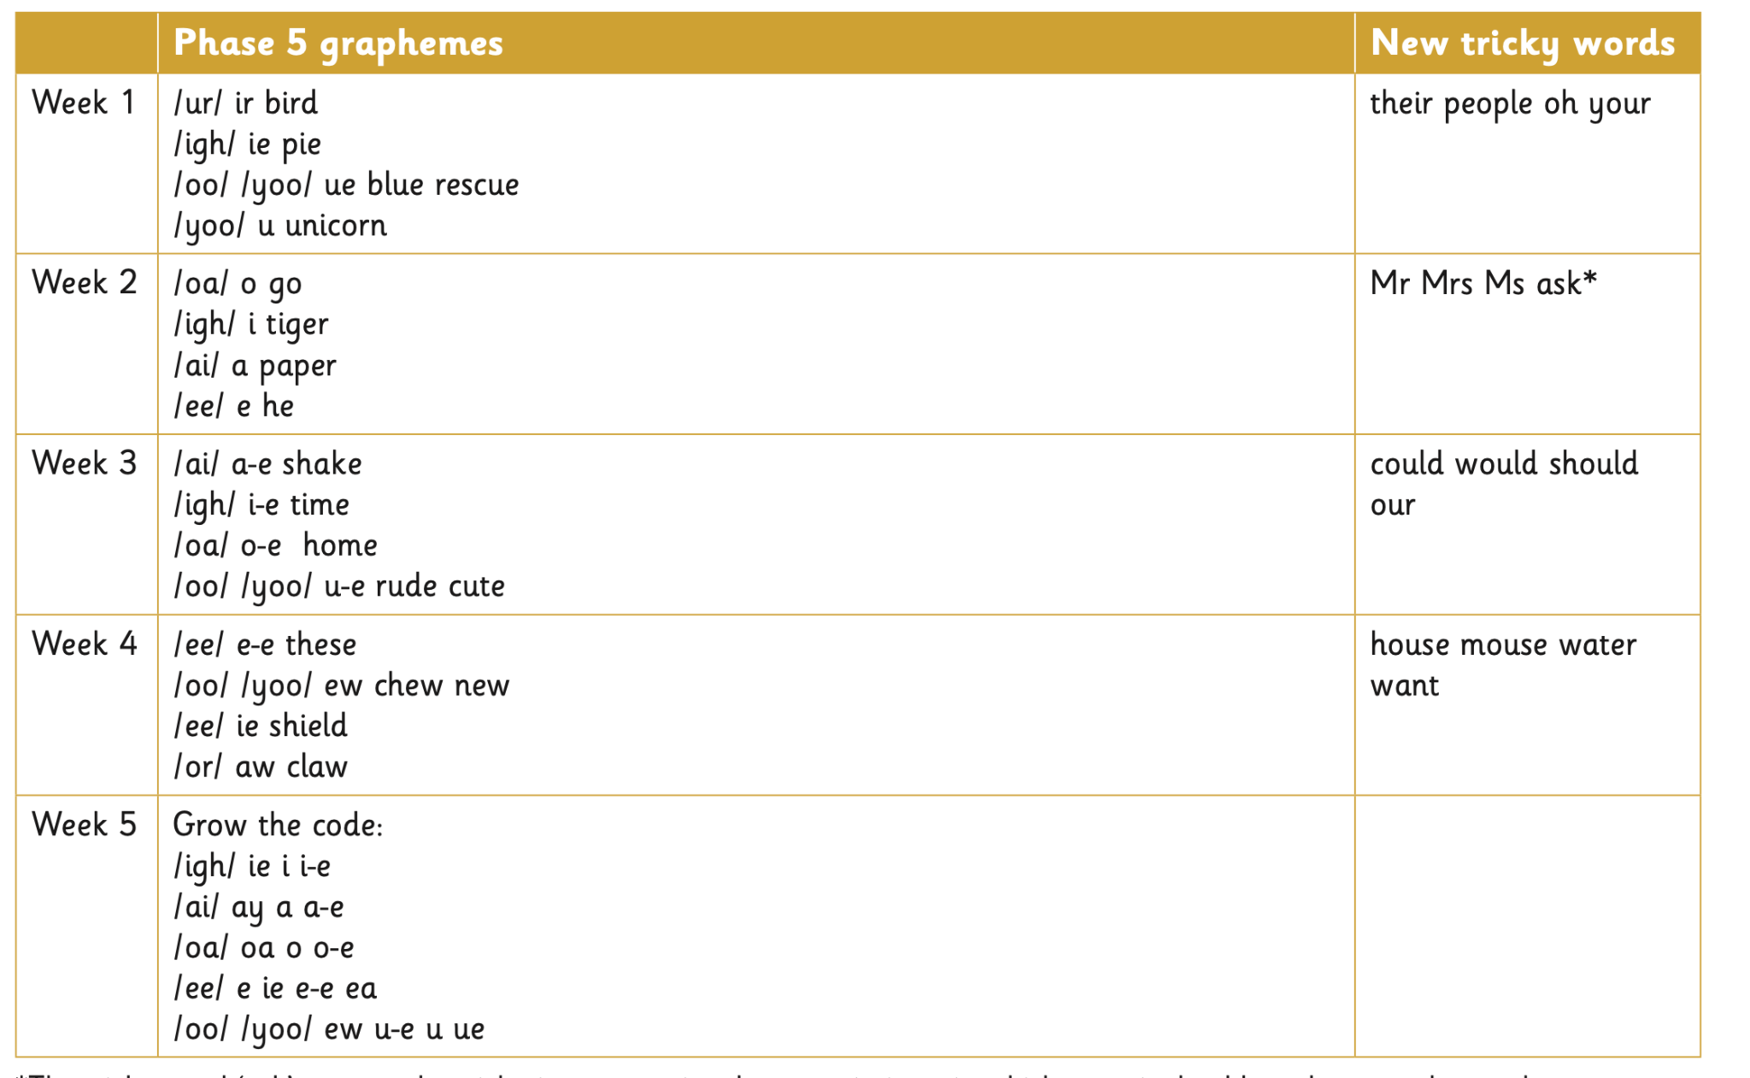

During Spring 1 of Year 1, your child will learn the following:

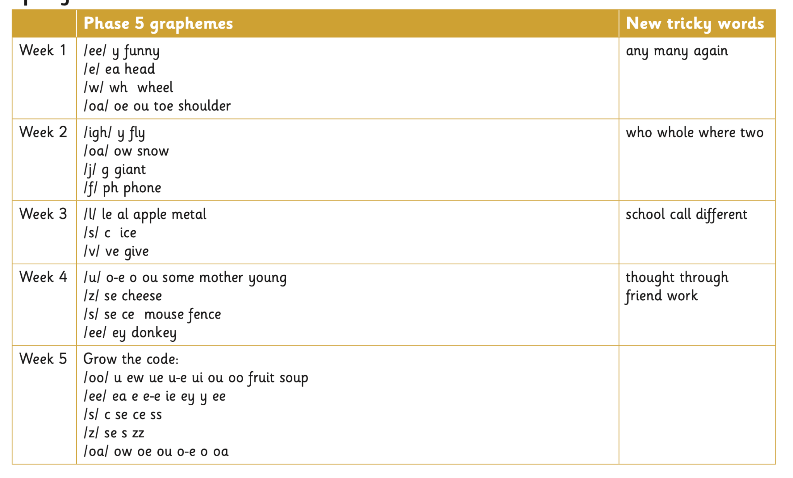

During Spring 2 of Year 1, your child will learn the following:

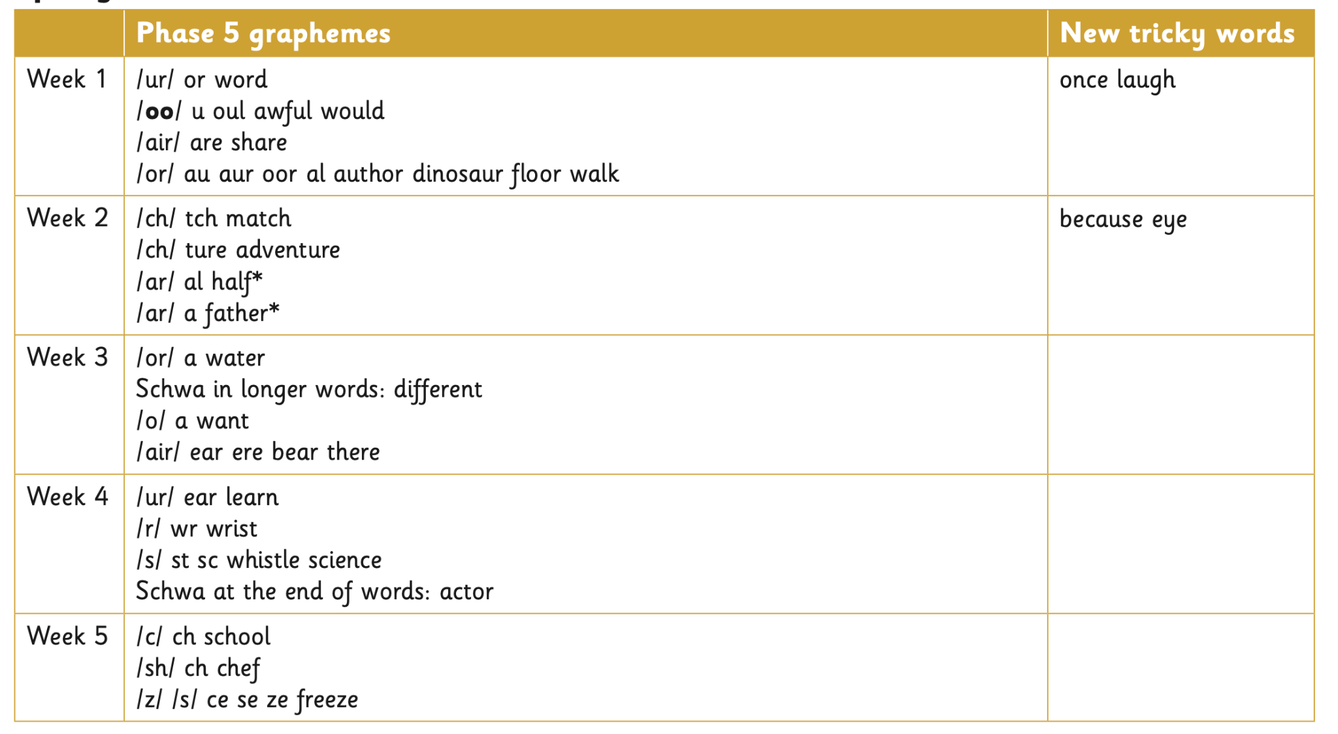

Summer 1 Content of learning
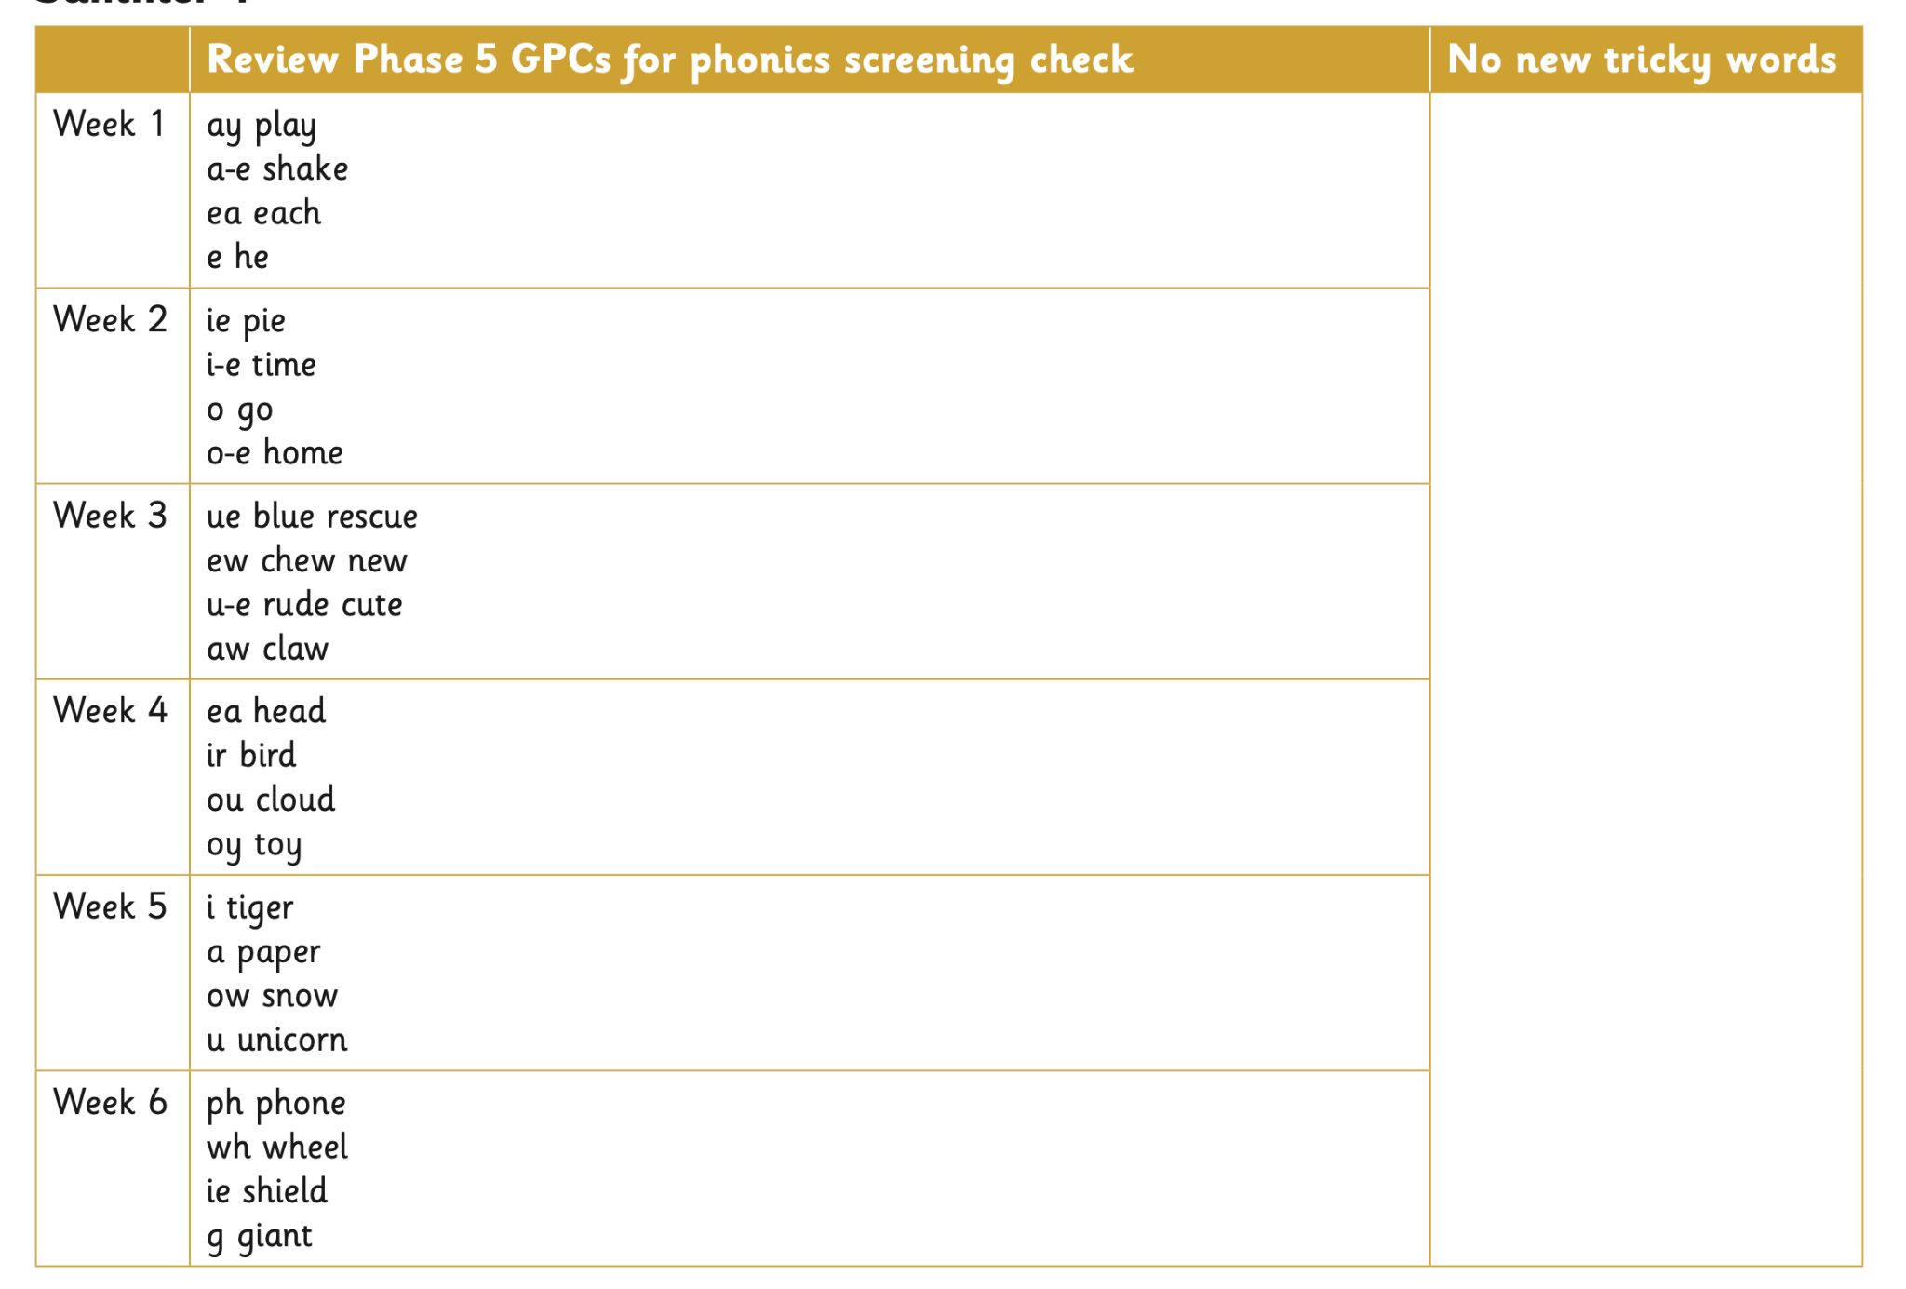

Summer 2:
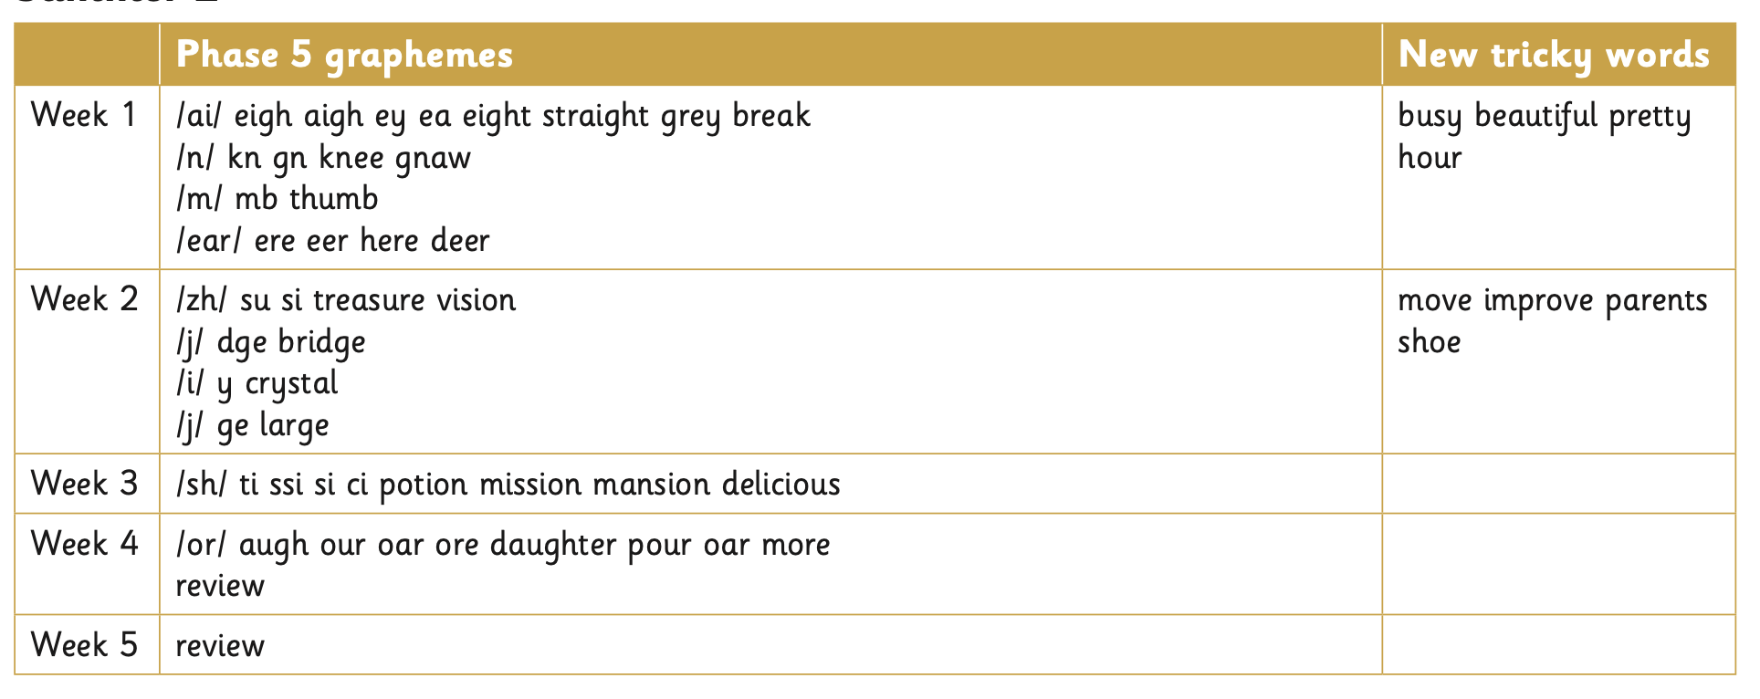
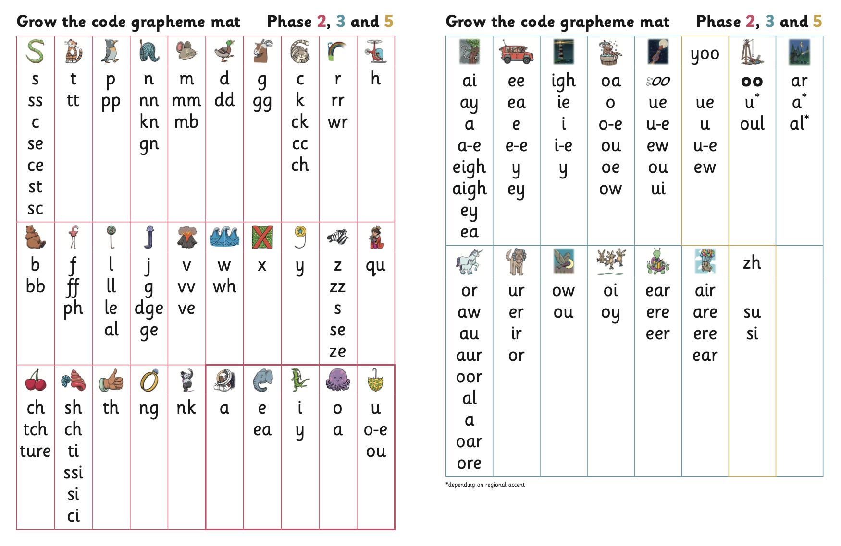

Alien words:
Alien Words Alien words are words that have no meaning and purely test whether a child can use their phonic knowledge (and nothing else!) to read the word. There are 20 alien words contained within the Year 1 Phonics Screening Check that takes place at the beginning of June in Year 1.

Year 2

As children move into Year 2, they will recap their phonics learning from Reception and Year 1 but then move on with their learning.
The children will be taught about:

* Prefixes
* Suffixes
* Past tense spelling – regular and irregular
* Tackling more unfamiliar words

